Bonalbo Central

School



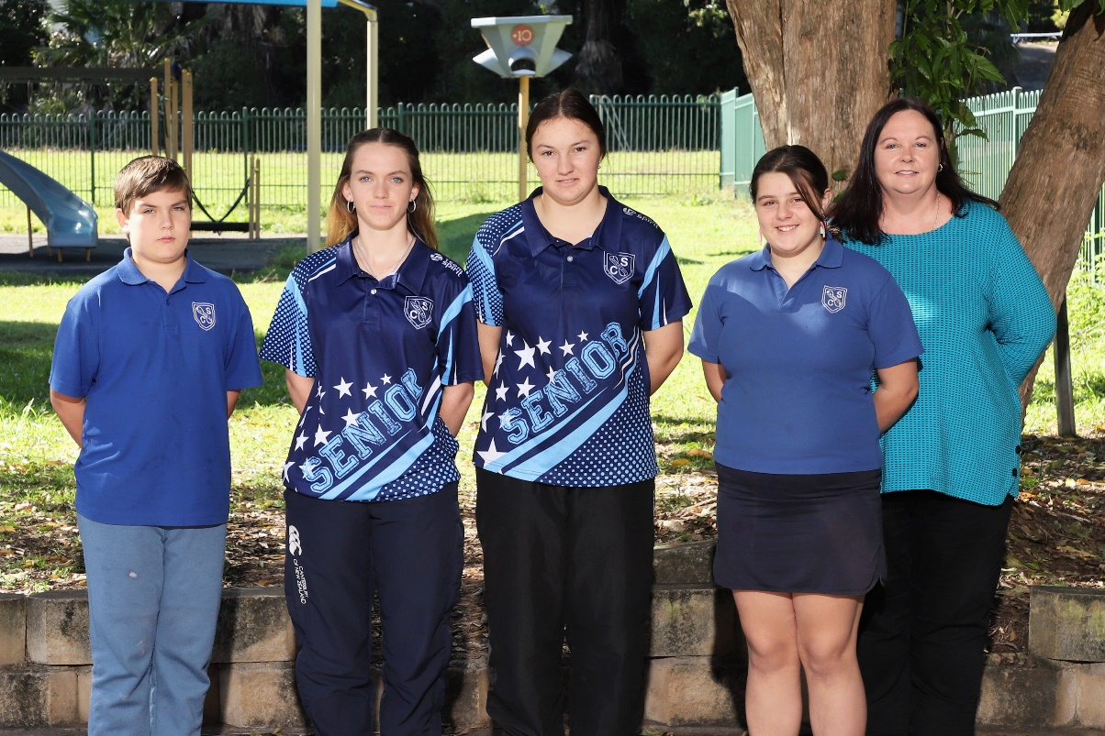

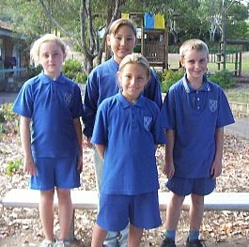INFORMATION BOOKLET

2017

2025

Telephone (02) 6665 1205

Office Hours 8.30am -3.30pm

**E-mail:** [**bonalbo-c.school@det.nsw.edu.au**](mailto:bonalbo-c.school@det.nsw.edu.au)

**School Motto**

Non Tibi Sed Scholae

which is Latin for "not for self but for school"

**School Song**

Come let us sing with honour

Of Bonalbo Central School

For learning, play and friendship

It sets a golden rule

And wherever life may take us

Even though it’s far away

We’ll remember our school motto

Non Tibi Sed Scholae

**School Expectations**

Be Safe

Be Respectful

Be a Learner

**School Values**

Respect

Integrity

Participation

Excellence

“Lifelong learning for a positive future”

**WELCOME TO BONALBO CENTRAL SCHOOL**

Bonalbo Central School is set on 10.2 hectares of grounds in the village of Bonalbo, NSW. The school caters for approximately 80 students from Kindergarten to Year 12 in a caring, family atmosphere.

The staff provide a comprehensive primary and secondary education for our students, within the curriculum guidelines set by the New South Wales Department of Education and the NSW Education Standards Authority. The school provides a smooth transition from Infants to Primary to Secondary, combined with monitored progress.

Class sizes are smaller than state average, particularly in the senior secondary school. Careers, learning and support teachers and a school counsellor are also on staff to assist and assess students.

The Primary (K-6) school is usually made up of two classes: K-2, 3-6. Staff are dedicated to providing the best educational outcomes with up-to-date resources and technology. Teachers and support staff are committed to providing programs for all levels of learning and the individual needs of students.

The Secondary (7-12) school has students entering Year 7 from our own primary school and our partner primary schools throughout the district (Tabulam, Old Bonalbo, Drake and Mummulgum). A broad curriculum is offered, catering to diverse educational needs.

In addition to the traditional subjects, BCS offers Vocational Education subjects such as Hospitality and Primary Industries in the senior school. We also have established links with Southern Cross Distance Education, Aurora College and TAFE. The school provides a safe caring environment where students can grow and learn. We have a strong school-wide focus on careers education, agriculture and wellbeing.

The school is well-equipped with a K-12 library, science laboratories, industrial arts trade training centre, full hospitality facilities, music suite and art facilities. Interactive whiteboards and laptops are available in all classrooms. Sporting facilities include an oval, netball/basketball courts, and a multi-purpose centre which incorporates a full-size basketball court. We also have an outdoor fitness station to support physical health and wellbeing. The school has access to a full-sized tennis court, cross country circuit, golf course, lawn bowls facilities and swimming pool. The school also has a 4.2-hectare agriculture plot located 300 metres from the main campus along with its on-site agricultural facilities.

Bonalbo Central School offers a well-rounded education to students of the Upper Clarence area of New South Wales.

We look forward to working with you and your family.

*Kathryn Taylor*

Principal

**Bonalbo Central School Staff- 2025**

PRINCIPALMrs Kathryn Taylor

ASSISTANT PRINCIPAL Mrs Kim James

HEAD TEACHERS SECONDARY Mrs Katrina Byrnes

Mrs Sharon White

SECONDARY STAFF Mrs Sharon White

English/History/Geography Ms Alicia Ducat

Ms Kay Clark

Science/Maths Mr Jason Anderson

Ms Larni Bird

Ms Kate Sheehan

TAS/CAPA Mrs Katrina Byrnes

Ms Alicia Ducat

Ms Kay Clark

PDHPE Mr Jaan Stolk

LEARNING SUPPORT Ms Lyn Davies

Ms Chris Kane

Mrs Annika Gray

PRIMARY STAFF Mrs Kim James

Ms Bronte Hewes

ANCILLARY Mrs Catherine Roffey - School Admin Manager

Mrs Rachel Moore - AEO

Mrs Wendy Johnston - SLSO

Mrs Belinda Makejev - SLSO

Mrs Melissa Armfield – SLSO/Hospitality

Ms Karyn Surman - SLSO

Ms Mandy Close – SLSO

Ms Jessica Mc Pherson- SLSO

Mrs Nicole Wright-Bernhagen – Library/Science

Mr Brett Holliday – Agriculture/General Assistant Mrs Kara Brown - School Administration

Mrs Kirsty Schache – School Administration/CLO

Mrs Kim Mills – School Administration

Mrs Michelle Bunney – School Administration

Mr John Sedman - Technical Support Officer

**A-Z OF GENERAL INFORMATION**

**(Things you need to know)**

**Assemblies**

**Whole School**

Presentation Assembly is held at the end of Term 4 (usually in the second last week) when Special Awards and the announcement of Dux and School Captains take place.

**Primary**

Assembliesare held twice a term, hosted by Primary Leaders. At times there may be a special assembly, such as during Book Week and Easter.

**Secondary**

A short checkout assembly is held at the end of each day and a slightly longer assembly occurs on Monday morning.

**Attendance**

All children have the right to an education. Only by regular school attendance can children make the most of educational opportunities, leading to greater social and economic outcomes. The *Education Act 1990* requires that parents and carers ensure that children of compulsory school age are enrolled at and regularly attend school. It is a legal requirement that all students attend school until the age of 17.

**Absences**

An explanation is required for **ALL** absences – including lateness/early departures from school. This can be by replying to the text sent by the school, a telephone call to the office, in person or by written note/email. If students are away for 3 days or longer for illness, a medical certificate is required.

Parents/carers must speak to the Principal if they wish to regularly pick up their child/ren early or if requiring an exemption from school.

**No student** **is permitted to leave the grounds at recess.** At lunch time students cannot leave without a lunch pass or note from parents. Students must sign out and back in at the front office.

**Start/Finish Times and Late Arrival/Early Departure Procedures**

**No student is to be at school before 8.30am in the morning, as there is no supervision before this time.** Primary staff are on duty in Primary from 8.30am, however, students must remain seated on benches until the bell rings at 8.45am.

*Any student who arrives late to school or needs to leave early must sign in/out at the front office and an explanation provided by parent/guardian.*

\* If your child has any change in the going home routine, the school must be notified either by a note to the teacher or contacting the front office prior to 3pm on the day of the change. If there has not been any notification, your child will be sent home under normal arrangements.

**Bells**

**Secondary Session Times**

|  |  |  |  |  |  |
| --- | --- | --- | --- | --- | --- |
| **Secondary Bell Times** | | | | | |
| **Period** | **Monday** | **Tuesday** | **Wednesday** | **Thursday** | **Friday** |
| Roll Call &  Check-in | 8.50 – 9.05 | 8.50 – 9.05 | 8.50 – 9.05 | 8.50 – 9.05 | 8.50 – 9.05 |
| 1 | 9.05 – 9.55 | 9.05 – 9.55 | 9.05 – 9.55 | 9.05 – 9.55 | 9.05 – 9.55 |
| 2 | 9.55 – 10.45 | 9.55 – 10.45 | 9.55 – 10.45 | 9.55 – 10.45 | 9.55 – 10.45 |
| Recess 1 | 10.45 – 11.00 | 10.45 – 11.00 | 10.45 – 11.00 | 10.45 – 11.00 | 10.45 – 11.00 |
| Recess 2 | 11.00 – 11.15 | 11.00 – 11.15 | 11.00 – 11.15 | 11.00 – 11.15 | 11.00 – 11.15 |
| 3 | 11.15 – 12.05 | 11.15 – 12.05 | 11.15 – 12.05 | 11.15 – 12.05 | 11.15 – 12.05 |
| 4 | 12.05 – 12.55 | 12.05 – 12.55 | 12.05 – 12.55 | 12.05 – 12.55 | 12.05 – 12.55 |
| Lunch 1 | 12.55 – 1.15 | 12.55 – 1.15 | 12.55 – 1.15 | 12.55 – 1.15 | 12.55 – 1.15 |
| Lunch 2 | 1.15 - 1.35 | 1.15 - 1.35 | 1.15 - 1.35 | 1.15 - 1.35 | 1.15 - 1.35 |
| 5 | 1.35 – 2.25 | 1.35 – 2.25 | 1.35 – 2.25 | 1.35 – 2.25 | 1.35 – 2.25 |
| 6 | 2.25 – 3.15 | 2.25 – 3.15 | 2.25 – 3.15 | 2.25 – 3.15 | 2.25 – 3.15 |
| End of day assembly | 3.15 – 3.20 | 3.15 – 3.20 | 3.15 – 3.20 | 3.15 – 3.20 | 3.15 – 3.20 |

**Primary Session Times**

|  |  |
| --- | --- |
| **Assembly** | 8:55-9am |
| **Session 1** | 9-10am |
| **Fruit Break** | 10-10:05am |
| **Session 2** | 10:05- 10:45am |
| **Recess** | 10:45am- 11:15am |
| **Session 3** | 11:15am- 12:55pm |
| **Lunch 1** | 12:55- 1:15pm |
| **Lunch 2** | 1:15-1:35pm |
| **Session 4** | 1:35- 3:10pm |

**Breakfast Club**

Breakfast Club operates everyday 8.30-9.00 am. This is supported by Foodbank and volunteers, allowing all food to be free to students.



**Buses**

Free bus travel is available to all children in Years K-2. Other students are eligible for free bus travel if they live a certain distance from the school depending on their year level.

* Students in Yrs. 3-6 - must live further than 2.3km or more by the most practicable walking route to the nearest point of entry to the school.
* Students in Yrs. 7-12 - must live further than 2.9km or more by the most practicable walking route to the nearest point of entry to the school.

**Application for bus travel must be submitted to** [**www.transportnsw.info/school-students**](http://www.transportnsw.info/school-students) **or phone 131 500. Alternatively, you may collect an application form from the front office.**

|  |  |  |
| --- | --- | --- |
| **BUS ROUTE -** | **BUS COMPANY** | **PHONE** |
| Drake, Pretty Gully | A K Quinn | 0419 142 224 |
| Old Bonalbo, Bonalbo, Peacock Creek, Bottle Creek, Tunglebung, Sandilands | CTC Buses | 0428 293 329 |
| Tabulam, Ewingar, Grafton Road | SB Coaches | 02 6666 1257 Depot |

**Behaviour on Buses**

The safety and comfort of all passengers travelling on buses is of primary importance. Bus operators and drivers are required to comply with occupational health and safety requirements and will take action if students put themselves or others at risk.

All students are expected to follow normal school rules and the Code of Conduct when travelling on buses.

**Students are to wear seatbelts.**

If a student misbehaves on a bus, the bus operator concerned will contact the parents and the school. Unacceptable and dangerous behaviour will not be tolerated, and the Company may refuse travel on school buses if behaviour is not acceptable. Students may also be suspended from school for unacceptable bus behaviour.

**Canteen**

The school has a well-equipped canteen providing inexpensive and nutritious food. It is open every school day. Students need to order their food before 9.00am. A full canteen price list is included in the enrolment package. Students are not allowed to go down the street to purchase food before or during school. There is no credit given so all purchases are to be paid for on the day.

**Careers Website**

As part of our K-12 Careers Education program, our careers website provides information for students and parents to explore career options through quizzes and questionnaires. Students can develop an understanding of their career interests and opportunities, and access work placement, work experience, TAFE and university information. Students can also create resumes and CVs in the students’ secure area.

**www. bonalbocentralschoolcareers.com**

**Celebrating Student Achievement**

Bonalbo Central School values and encourages positive behaviours from all its members. As such, our Merit System is built on our expectation of safety, respect, being a learner.

Student achievement is based upon opportunity and engagement. Bonalbo Central School strives to ensure all students are given as many opportunities as possible to display their skills and abilities. These opportunities occur in the classroom, on the sporting field, in cultural activities and in community service.

Our teachers strive to fully develop the talents and capacities of all students in pursuit of attaining the highest educational standards. The diligence and sustained efforts of students, supported by accomplished teachers using explicit teaching principles, are key factors for student success.

The school has a range of structures to identify and celebrate the achievements of our students.

**Primary**

Students in primary have various in class rewards systems. Termly reward activities are offered to students based on their positive behaviours and improvement.

**Secondary**

Students displaying our guiding values are awarded tickets for the weekly reward. These accumulate each term for the end of term activity.

**Whole School Achievement**

All students K-12 are acknowledged at a Half-Yearly Achievement and Yearly Presentation Assemblies where students who have gained academic success are celebrated. Students who have excelled in the sporting arena and a variety of Special Awards for both Primary and Secondary are also presented. Our P&C contribute to awards for students based on their commitment to school values and students who volunteer in community or school events are also recognised. Aboriginal Education Officer awards are presented to First Nations students who have represented the school and community with commitment and success.

**Change of Details**

It is vital that parents/carers keep the school informed of any change of details. This includes medical information, phone/address details and emergency contact**Code of**

**Conduct**

NSW public schools are committed to providing safe, supportive and responsive learning environments for everyone. We teach and model the behaviours we value in our students.

Students are expected to:

* Show respect to other students, their teachers and school staff and community members
* Follow school and class rules and follow the directions of their teachers
* Strive for the highest standards in learning
* Resolve conflict respectfully, calmly and fairly
* Meet the school’s agreed uniform policy or dress code
* Attend school every day (unless legally excused)
* Respect all property
* Be safe and not be violent or bring weapons, illegal drugs, alcohol, vapes, e-cigarettes or tobacco into our schools.
* Not bully, harass, intimidate or discriminate against anyone in our schools

**Enrolment**

All enrolling students are required to attend a face-to-face interview with the Principal. Proof of residency, age (e.g. birth certificate) and immunisation certificate (Primary and Year 7) are required and parents are required to complete an enrolment form. When enrolling your child, you will be asked to complete the following forms that give the school essential background information as well as authority to take appropriate action in case of medical emergency.

1. Enrolment Application
2. Permission Notes
3. Bus Application (if required)

**Excursions and Sport**

A variety of excursions, camps and sporting trips are organised by the school during the year. Students taking part must be in full school uniform or suitable attire and must return their signed permission notes and money (if required) before they will be allowed to leave the school. The School Bytes app is used for all notes and payments. Students who have been suspended may be ineligible to participate.



[This Photo](http://www.pngall.com/basketball-png) by Unknown Author is licensed under [CC BY-NC](https://creativecommons.org/licenses/by-nc/3.0/)

**Facebook Page**

Our school ‘s Facebook page can be accessed at www.facebook.com/bonalbocentralschool

**Health**

**Accidents or Illness at School**

If a student has an accident or becomes unwell at school, parents will be notified as soon as possible. Should the school be unable to contact parents/carers or emergency contacts, and if medical assistance is required urgently, the school will take emergency action to support the student. **If your child has a medical condition or disability, we should be informed. Please advise us, e.g. allergies, asthma, hearing or visual difficulties etc.**

**Children’s Infectious Diseases**

A detailed list is provided at the back of this booklet. The [Public Health Act 2010](http://www.legislation.nsw.gov.au/#/view/act/2010/127/full) requires that certain medical conditions be notified to public health authorities in NSW

**Health Care Plans**

If your child has a health care plan, please provide it to the school on enrolment.

**Immunisations**

Children starting school in Kindergarten and Year 7 must present an Immunisation History Statement at the time of enrolment. Community Health conducts immunisation programs for Junior Secondary students at school. Details of these programs will be outlined and permission required before any immunisations can take place.

**Medication Procedure**

If your child requires medication whilst at school, parents/carers are asked to come to the front office and complete a prescribed medication form that outlines the dose required and specific instructions. Medications are to be held at the front office. These requirements also apply to Paracetamol.

**Homework**

The development of home study skills becomes increasingly important as a student progresses through senior primary and secondary years.

**Primary**

Homework is set regularly and is designed to assist learning. Homework in Primary varies in nature and purpose. It also varies according to each classroom teacher and the children’s abilities. We encourage parents to read with their children each night.

**Secondary**

In high school, homework enables students to develop habits of reviewing work undertaken in class and looking ahead to future lessons. Homework will be set on a regular basis in each subject. Homework could require between 45-90 minutes per school night.

**Parents and carers can help by:**

* taking an active interest in homework
* ensuring that there is time set aside for homework
* encouraging and supporting students to complete homework
* providing, where possible, a dedicated quiet place for homework and study
* encouraging children to read and take an interest in current events
* assisting teachers to monitor homework by signing completed work if requested and being aware of the amount of homework set
* communicating any concerns about the nature of homework and their children’s approach to the homework with teachers
* alerting the school to any domestic or extracurricular activities which may need to be taken into consideration.

**Library**

The library caters to the learning needs of Years K to 12 by providing opportunities for students to foster a joy of reading through a variety of traditional and digital methods and to develop their research skills to enable all our students to develop into 21st Century learners and thinkers. There is also a Careers’ Corner, providing a wealth of career and further study information!

To ensure that all the books in our collection are accessible for all students, it is important that students are aware of the loan limits for their year group, which are:

**K/1:** maximum of 2 books to be borrowed at any one time (generally, this year group would not take their books home).

**Years 2-6:** maximum of 2 fiction books and 2 non-fiction books to be borrowed at any one time.

**Years 7-8:**  maximum of 3 fiction books and 3 non-fiction books to be borrowed at any one time.

**Years 9-10:** maximum of 4 fiction books and 6 non-fiction books to be borrowed at any one time.

**Years 11-12:** maximum of 6 fiction books and 10 non-fiction books to be borrowed at any one time.

**Lost property**

All items of clothing and personal items such as pencil cases, lunchboxes, etc. are to be clearly labelled. The school continually has items sent to lost property in the Front Office.

**Lunch Passes**

Local secondary students who wish to go home for lunch must ensure they have a Lunch Pass. These are available from the Front Office and require a note from a parent/carer first.

**Mobile Phones**

**Primary students are not to have a phone or any mobile device at school.** All electronic devices are to be handed into the front office at the start of the day.

**Secondary is a phone-free space through the use of *Yondr* pouches.**

The *Yondr* Program uses a simple, secure pouch that stores a phone. Every student will secure their phone in a personally assigned *Yondr* Pouch when they arrive at roll call. Students will maintain possession of their phones but are not to use them until their pouches are opened at the end of the school day.

The school loans one *Yondr* Pouch free to every secondary student whilst they are enrolled. However, if the Pouch is damaged, or lost, students will need to pay a $15 replacement fee.

If a student normally uses their phone for medical purposes (i.e. to check their sugar levels if they are diabetic), their Health Care Plan will need to be updated and allowances will be made on a case-by-case basis. Please contact the school to discuss.

Parents/carers can still reach their child/ren by contacting the Front Office on 6665 1205.



**Newsletter/Bulletin**

This publication can be accessed via our website. Students are also given hard copies at the end of each term, with smaller bulletins throughout the term.

**NAPLAN**

Students in Years 3,5,7&9 participate in the National Assessment Program – Literacy and Numeracy (NAPLAN) annually in Term 1 using an online platform.

**Parents & Citizens Association**

The P & C are a valued and important component of our school community. Their enthusiasm, hard work and support provide ideas and fundraising opportunities to assist with the successful running of the school. The school values a high level of community and parental involvement. Parents/carers are invited to become involved in the formulation and development of new school policies and strategic directions, through the P & C. New members are always very welcome.

Meetings are held every 2nd Wednesday of the month at 3:30pm. For further information, please contact the P & C President via the Front Office.

**Parental Involvement**

Parents are invited to attend the regular primary assemblies and any special assemblies such as the Induction of Student Leaders, Anzac Day Commemoration and Presentation Assemblies. Parents can be involved in classroom activities and the transportation of students for sport/excursions.

Volunteers provide a valued contribution to the teaching and learning programs in our school. If you are interested in being a volunteer, please contact the school regarding Working With Children Check and screening requirements. All voluntary classroom helpers are to sign in at the Front Office on arrival and sign out on departure. All visitors to the school must obtain the Principal’s permission and are requested to wear an “Official Visitor” lanyard.

**3-Way Conferences**

3-Way conferences between student, teacher and parent/carers are a part of our reporting procedures. They are held late Term 1 and Term 3. They enable the sharing of information and opportunity to discuss progress, achievements and concerns.

**Permission Notes and Money**

**Primary**

Green notes are for ACTION. This means they must be signed by parents/carers and returned to school as soon as possible. When forwarding permission notes and/or money to school please ensure that these are enclosed in a sealed envelope with your child’s name and the amount enclosed. These can be given to their teacher at roll call or handed to the Front Office before this time.

**Secondary**

Permission notes and money are to be handed to the Front Office.

**Photographs**

School photos usually occur late Term 1. All students will be photographed and parents/carers have the option to buy packages.

**Private Vehicle-School Drive Subsidy**

Parents conveying children more than 1.6 km (Primary) and 2km (Secondary) to the nearest bus stop or school may be entitled to a ‘per trip payment’ subsidy. For more information or to apply please call 131 500 or visit the Transport for NSW website transport.nsw.gov.au/schooldrive

**Private Vehicle Use by Parents Conveying Students on Excursions**

To consider the use of private vehicles by parents transporting students on school excursions, the following points will be considered before authorisation is given:

1. The vehicle must be registered (a copy is to be provided)

2. The driver must be licensed to drive that particular vehicle (a copy is to be provided)

3. The vehicle should only convey the number of students for which it has seat belts fitted or is registered to seat

4. Parents must be advised and approve of the travel arrangements made

5. A Child Protection Declaration must be completed and identification provided.

In the case of volunteers/senior students using private vehicles, the school will require the following conditions:

1. The vehicle is registered - insurance is a matter for the vehicle owner; however, it is definitely preferable for the vehicle to be comprehensively insured (copies are to be provided)

2. The driver must be licensed to drive that particular vehicle (a copy is to be provided)

3. The vehicle should only convey the number of students for which it has seat belts fitted or is registered to seat

4. Parents must be advised and approve of the travel arrangements made

5. A letter from the senior student driver’s parents/carers acknowledging that the student will be driving the vehicle and only carrying passengers as outlined

6. A letter from any passenger’s parents/carers acknowledging that their child/ward will be travelling with the identified senior student driver.

If you have any enquiries regarding these procedures, please contact the school.

**Reports and Student Progress**

The school uses a program of continuous assessment for each student. Formal school reports are issued twice each year and there are 3-Way conferences to discuss student progress throughout the year. Parents/carers are encouraged to contact the school to organise to meet classroom/subject teachers to discuss any concerns at any time.

**School Development Days**

School development days enable the whole school staff to participate in a range of activities aimed at the overall development of the school. These could include: the school’s improvement plan, setting goals and objectives, curriculum changes, student wellbeing programs, mandatory training etc. Parental involvement in these days is welcomed, when the program is relevant.

Schools are entitled to eight (8) school development days per year. These are normally scheduled at the beginning of each term, with four at the start of the year.

**School Bytes App**

School Bytes provides a parent portal to help our school communicate with you. You may use the parent portal for various things including online permission notes, attendance and payments, which can be accessed via a secure link. The School Bytes parent portal enable you to view all your children in one portal and process payments for multiple siblings in one transaction.



**Sport**

Sport and PE are mandatory parts of the curriculum and play an important role in the total education of students. As Sport is compulsory, all students, unless prevented by health reasons, must participate. Primary sport is held on Friday afternoon and Secondary sport is on Wednesday afternoon.

We have an excellent range of sport facilities and equipment including a 7-stage gym to encourage physical fitness.

The school offers a wide variety of extracurricular sports for students to choose from. Participation in regional sporting activities, state competitions and Central Schools Gala days is encouraged. Primary and Secondary house teams compete at the Swimming Carnival in Term 1 and the Athletics and Cross Country in Term 2.

**Houses**

When children enrol, they are allocated to one of our School Houses:

***HOUSE COLOUR ALPHABET (by surname)***

Bruxner Bandits Red A-K

Clarence Crusaders Green L-Z

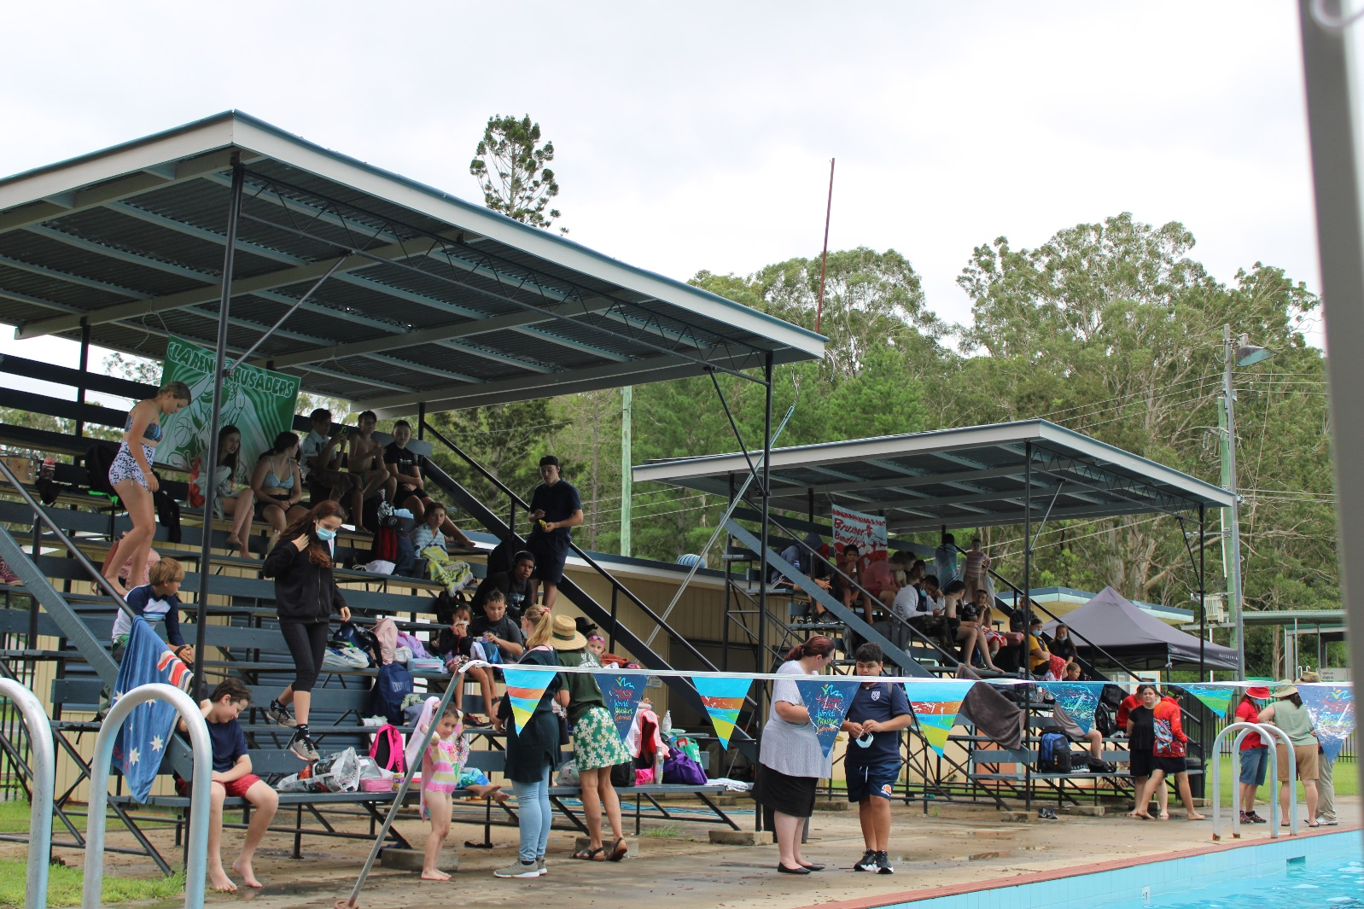

**Stationery**

Students receive a stationery requirement list in the enrolment package. Scientific calculators are available for $32 at the Front Office. All students are required to have a USB Thumb Drive.



**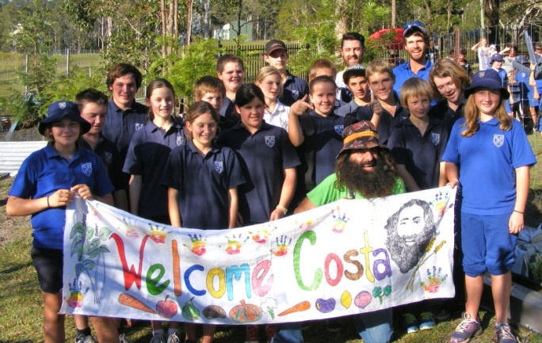Student Representative Council and School Captains**

The school follows the policy that there will be greater commitment to school life if students have a say in the running of the school. Each class has student representatives who meet regularly as a Primary or Secondary Council to discuss school matters, fundraising and social events.

School and house captains are voted for by students and staff, and represent the student body at both in-school and community events.

**Supervision**

**Students should not be in school grounds before 8.30am**.

**Primary Students**

On arrival at school, students must be seated on the primary benches until the play bell at 8.45am. Primary staff are on duty in Primary from 8.30am, however, students must remain seated on benches until the bell rings at 8.45am.

**Secondary Students**

No supervision of students is provided before 8.30 am or after 3.30 pm, and no student should arrive at school before that time or remain in the school grounds after school ends for the day. Between 8.30 am and the commencement of classes, any student with a problem should report to a Head Teacher or the Principal, who are generally to be found in their offices.

**Bus Duty**

A teacher supervises primary and secondary students at the bus stop in the afternoon from 3.20pm. Primary children are escorted to the buses by a staff member. Primary students who walk home are escorted across the pedestrian crossing.

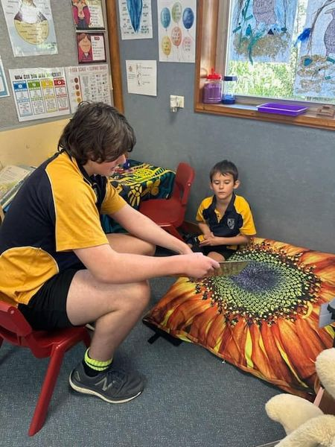

**Uniforms**

Bonalbo Central is a “uniform wearing” school and takes pride in the way that its students can present themselves. Financial assistance may be provided upon request for the provision of uniform items.

Uniforms can be purchased from the Front Office between 8.30am & 3.30pm on school days. Some second-hand uniforms are available.

**School Uniforms**

**Primary**

* Royal or Navy blue shorts (not denim), skirt or track pants
* Royal blue shirt
* Navy blue hat
* Royal blue polar fleece jumper

**Secondary 7-12**

* Navy or black shorts (not denim or leggings), skirt (A-Line) or long pants
* Navy shirt
* Navy polar fleece jumper

**Sports Uniform K-12**

To be worn only on sports days and when representing the school.

* Appropriate navy blue or black pants (not denim) or tracksuit pants
* School sport shirt
* Joggers
* Hat

# All shirts and jumpers embroidered with the school crest.

|  |  |  |  |
| --- | --- | --- | --- |
| **PRIMARY** | **Price** | **SECONDARY** | **PRICE** |
| 1. Shorts sizes 4-16 | **$12** | 1.Polo Shirt Navy- Sizes 12-16Y | **$20** |
| 1.Polo Shirt Navy- Sizes 14S upwards | **$22** |
| 1. Shirt – Royal Blue 4-16Y 2. – Royal Blue 14S- XXL | **$20**  **$22** | 2. Polar Fleece Jumper – Navy Size12-16Y | **$25** |
| 1. Jumper – Royal Blue 6-16Y Polar Fleece | **$25** | 2. Polar Fleece Jumper- Size 14S-26/3XL | **$30** |
| 1. Hats – Broadbrimmed | **$5** |
| 1. Trackpants (we hold 6-10) | **$20** | 3. Sport Shirts- to Size 16Y | **$24** |
| 1. Sports Shirt 4-16Y   Sports Shirt 14S upwards | **$24**  **$30** | 3. Sport Shirts- 14S upwards | **$30** |
|  |  |

**Hats**

Primary has a policy of “No Hat, No Play”. It is also strongly recommended that secondary students wear a school hat or cap for general comfort and to minimise the risk of sunburn and skin-cancer in summer.

**Jewellery and Make Up**

Jewellery and make up are to be kept to a minimum and must not pose a risk to the wearer or others. All jewellery is worn at the students’ own risk and students may be asked to remove excessive jewellery and make up.

**Shoes**

All students should wear sturdy shoes that provide protection for their feet. The school encourages students wear leather shoes with enclosed toes for all classes and school activities.

Closed toe leather shoes must be worn in the secondary department in all practical lessons e.g. Food Technology, Hospitality, Science, Art, Industrial Technology and Agriculture. This is a Department of Education Health Safety requirement.

*Please note that there is a strong recommendation students wear black leather shoes in preference to joggers. Many joggers are similarly priced to leather but are not as hygienic or as longwearing.*

**Website + Sign**

Our regularly updated school website [www.bonalbo-c.schools.nsw.edu.au/](http://www.bonalbo-c.schools.nsw.edu.au/) provides information for students, parents/carers and community members from both our school and the NSW Education Department.

The large electronic sign on Woodenbong Road also keeps our community updated.

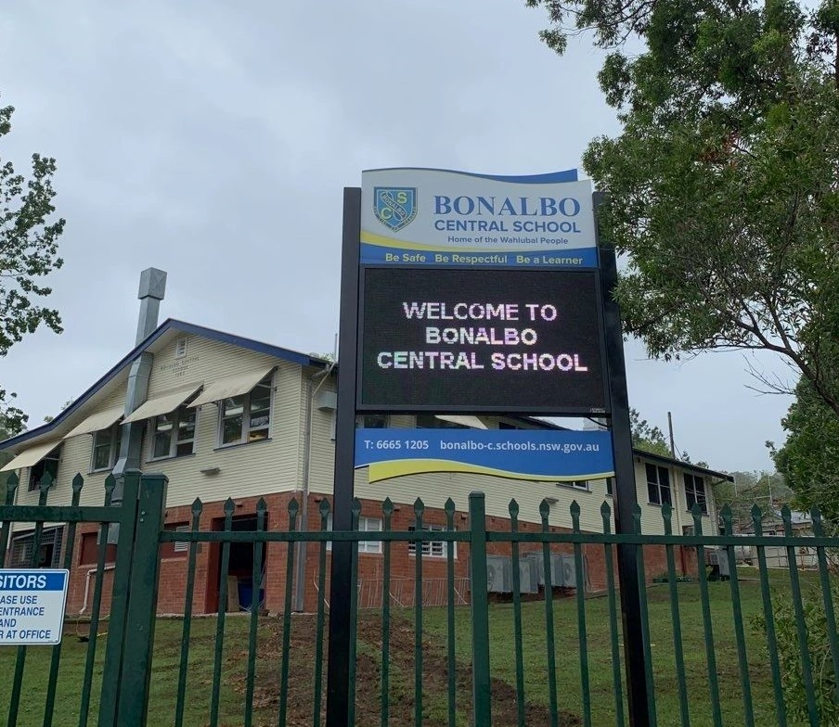

**Wellbeing**

The school consciously works to build the self-esteem and mental health of all students through recognition of effort whenever the opportunity arises. Students are encouraged to respect the rights of others and to take responsibility for their own actions. Proactive programs are in place and sessions are run regularly to support positive wellbeing and mental health.

Parents are encouraged to contact the school if there are welfare issues we should be aware of. Wellbeing and Learning Support meetings occur weekly to discuss students and plan for support structures. We also have School Learning Support Officers who help students with particular needs.

**Check-In**

Daily check-in encourages students to interact with their peers and staff on a range of issues, including personal wellbeing, social issues and current events. Students engage in meaningful conversations and activities around the school’s expectations.

**School Counsellor**

Our School Counsellor visits weekly and all new students are introduced to the School Counsellor. The School Counsellor is available for students and parents to discuss issues of concern to them, along with providing advice and information.

**ADDITIONAL PRIMARY INFORMATION**

**Best Start**

It is very important to emphasise that *Best Start Kindergarten Assessment* is not a test. Its purpose is to help the teacher gather information to guide the teaching of your child when they first start kindergarten.

We will observe each child and use tasks in Numeracy and Literacy, such as talking about a book that has been read, and record what your child knows and can do. This is a state-wide program required by the Department of Education. All parents/carers will be given feedback about their child’s results.

**Hats**

The school has a No Hat/No Play policy. Any student without a hat will be required to sit in the designated shaded area during play time. Primary students will be provided with a sun-safe bucket hat free of charge courtesy of our P&C. This hat MUST be worn. If this hat is lost/damaged, replacement hats are available for $5 from the Front Office.

**Key Learning Areas**

Primary staff organise their weekly teaching around the KLAs of English, Mathematics, Science and Technology, History and Geography (HSIE), Personal Development, Health and Physical Education (PDHPE), and Creative and Performing Arts (CAPA). We include outcomes from Languages Other Than English (LOTE) in our HSIE Cultural Studies program. Students participate in the yearly CWA Country of Study Competition. Students also benefit from Secondary staff expertise in areas such as Music, Art, Library, Science and PE when whole-school staffing allows.

**Library**

All primary students attend weekly Library sessions. Students wishing to borrow from the library need to have a Library Bag. A pillowcase or green bag are suitable choices.

**Transition**

Children’s perceptions of themselves as learners, and as someone who belongs at school, are often formed early in their schooling.

Our Preschool to Kindergarten transition program (“Take off into Kindy”) involves activities for preschool students, Kindergarten and teachers (along with parents/carers) to gain insightful information about the school and students. This includes building a positive and supportive rapport before school commences.

Evidence suggests that children who have a positive start to school are more likely to engage well and to experience academic and social success. Transition to school may be a child’s first experience of social interaction with others outside of their immediate or extended family.

Bonalbo Central School Preschool to Kindergarten Transition program commences in Term 3 and continues throughout Term 4 each year.

**Variation to Routine**

**If your child has any change in the going home routine, the school must be notified, either by a note to the teacher or by contacting the front office before 3 pm.** If there has not been any notification, your child will be sent home as per their usual routine.

**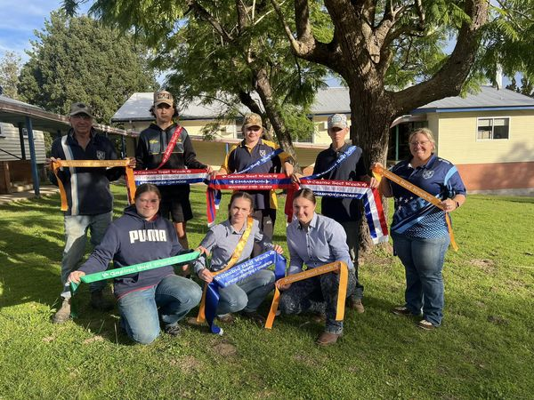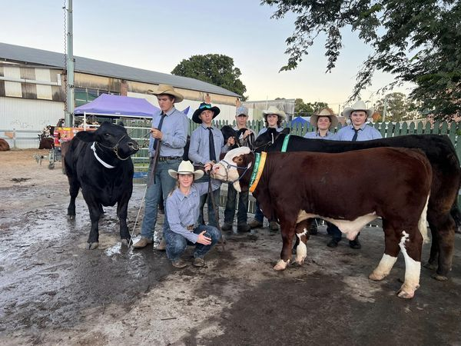**

|  |  |  |
| --- | --- | --- |
| **ADDITIONAL SECONDARY INFORMATION**  **Assessment of Students**  **Years 7 - 10**  All students are expected to participate in all set learning activities and to complete all assessment tasks.  • When students fail to complete assessment tasks on time or to a satisfactory standard, parents/carers will be notified. In Stage 5 (Years 9 & 10) this may have serious consequences for the award of the RoSA and continuing into Stage 6.  • In each subject, students are advised on how particular outcomes will be assessed and how this will contribute to their achievement at a satisfactory level through assessment schedules and task sheets.  • Reports contain a series of grades and marks indicating progress in achieving the outcomes prescribed by NESA for that particular subject.  • Rules concerning the RoSA are issued separately to senior students. Parents/carers should not hesitate to contact the school if they have any concerns about their students meeting these guidelines.  **Years 11 and 12**  • All students are expected to participate in all set learning activities and to complete all assessment tasks.  • ‘N’ Awards are a NESA (NSW Education Standards Authority) requirement to indicate to students and parents/carers that they are at risk of not completing a course. These are sent home if students have failed to complete an assessment task on time or to a satisfactory standard.  • The reports, following trial or final examinations, are based on examination and assessment task results. Stage 6 assessment policies and procedures are outlined in the HSC Assessment Policy booklets issued to students at the beginning of their course.  Parents/carers are invited to contact the school anytime, if they have concerns about their child’s performance, behaviour etc.  **Curriculum**  In Stage 4 (Years 7 & 8) all students follow courses in English, Maths, Science, History, Geography, Music, Visual Art, Mandatory Technology, PD/Health/PE and LOTE.  All students in Years 9 & 10 (Stage 5) will follow courses in English, Maths, Science, PD/Health/PE, History and Geography. In addition, students select three subjects from the following electives: Agriculture, Industrial Technology Timber, Visual Art, Music, Physical Activity & Sports Studies, Food Technology, Aboriginal Studies and Photography and Digital Media.  **Distance Education**  Students in Stage 6 who wish to study a single subject that is not offered at Bonalbo Central School, or that clashes on a line with another desired subject, may do so via Distance Education or Aurora College if it is available. A fee applies for these subjects. A teacher on staff may be available to assist with students studying this way. Please contact the school for more information.  **Higher School Certificate & RoSA (Record of School Achievement)**  The HSC is awarded to students who successfully complete Year 12, having studied the right number and types of courses, completed assessment tasks, achieved minimum literacy and numeracy standards and sat for the required HSC examinations.  Students who leave school at the end of Year 10 or any time up to but not completing their HSC are awarded a RoSA. The RoSA is a cumulative credential showing Year 10 grades and any Year 11 grades for (Preliminary) courses completed. For further information, please contact the school.  **HSC Minimum Standards**  Each student in Year 11 will undertake minimum standard testing. This assesses the students academic level in reading, writing and numeracy. Employers can use this tool to rank students for employment.  **TAFE and School**  Vocational Education TAFE Courses are available for senior students wanting to study one or more TAFE subjects as part of their Higher School Certificate.  Vocational courses are growing rapidly and are offered both by TAFE and the school. Many of these courses offer students dual accreditation for TAFE and the HSC.  A growing number of students are also combining part-time work with their studies by undertaking a School Based Apprenticeship or Traineeship. Please contact the school for further information.   |  |  | | --- | --- | | |  | | --- | | **C:\Users\mallen35\Desktop\Too sick for schoolFINAL_Page_1.jpgC:\Users\mallen35\Desktop\Too sick for schoolFINAL_Page_2.jpg** | | |

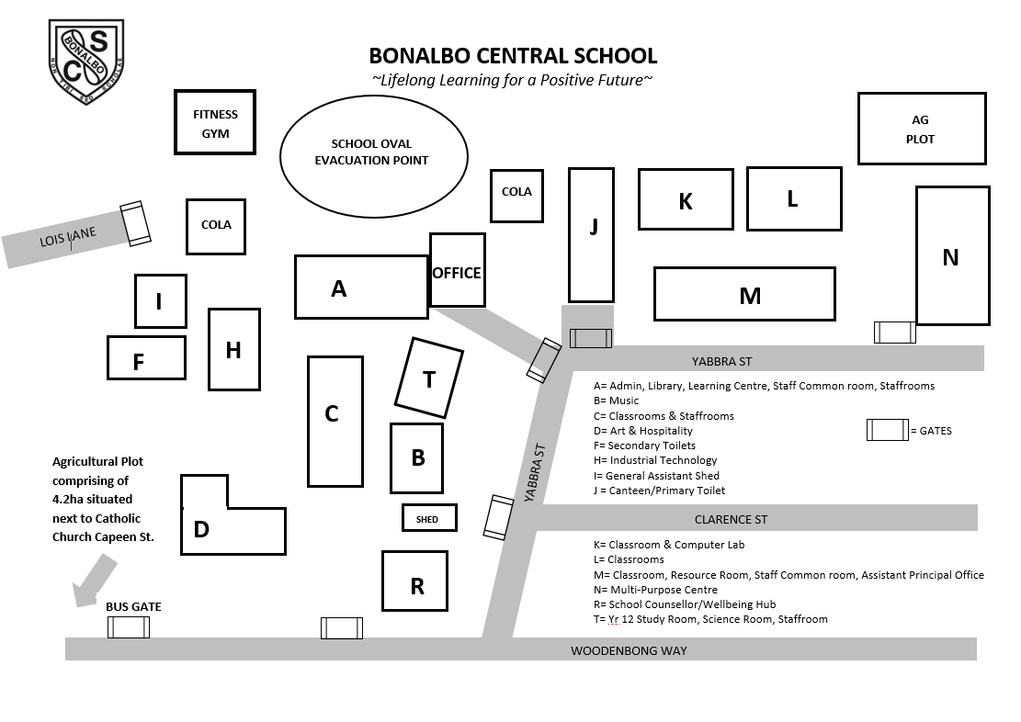

Main Entrance

Bonalbo Central School

Canteen Menu 2024

|  |  |
| --- | --- |
| **Sandwiches** |  |
| *Vegemite* | $2.50 |
| *Cheese* | $3.00 |
| *Ham & Cheese* | $3.50 |
| *Ham, Cheese & Tomato* | $4.00 |
| *Chicken, Lettuce & Mayo* | $4.00 |
| *Meat & Salad* | $5.00 |
| *Toasted Extra* | $1.00 |
| *Wrap extra* | .50c |
|  |  |
| **Wraps** |  |
| *Ham and Salad* | $5.00 |
| *Chicken and Salad* | $5.00 |
| *Chicken Tender Wraps (s/chilli, plain)* | $6.00 |
|  |  |
| **Salad Bowls** |  |
| *Plain* | $6.00 |
| *Meat – Ham, Chicken* | $7.00 |
|  |  |
| **Hot Foods** |  |
| *Chicken Nugget* | .70c |
| *Fish Bites* | .80c |
| *Mini Pie* | $1.50 |
| *Plain Chicken Tenders* | $2.00 |
| *Sweet Chilli Chicken Tenders* | $2.00 |
| *Sausage Roll* | $4.50 |
| *Chicken & Gravy Roll* | $5.00 |
| *Beef Pie* | $6.00 |
| *Beef, Cheese & Bacon Pie* | $6.50 |
| *Pepper Steak Pie* | $6.50 |
| *Hot Dog* | $4.50 |
| *Hot Dog + Cheese* | $5.00 |
| *Lasagna* | $5.50 |

|  |  |
| --- | --- |
| **Drinks** |  |
| *Water* (600ml) | $2.00 |
| *Popper’s* (200ml) | $2.50 |
| *M2GO* (choc, straw) (250ml) | $3.00 |
| *Juice Bombs* (Grape, Rasp, Apple Cola, Orange & Pash, Watermelon) (250mls) | $3.00 |
| *Hot Milo* (250ml) | $1.50 |
|  |  |
| **Frozen** |  |
| *Snap Stick* (70ml) | $1.00 |
| *Frozen Yoghurt* (straw, choc w/melon) | $3.00 |
| *Vanilla Ice Cream Cup* (100ml) | $2.00 |
| *Moosies* | $2.00 |
|  |  |
|  |  |
| **Snacks** |  |
| *Plain or Salt & Vinegar Chips* | $1.50 |
| *Grain Waves* | $1.50 |
| *Original Popcorn* | $1.00 |
|  |  |
| **Homemade (All Subjected to availability)** |  |
| *Bacon & Egg Muffin* | $5.00 |
| *Fried Rice* | $5.00 |
| *Spaghetti Bolognaise* | $5.00 |
| *Curry Sausages* | $5.00 |
| *Carbonara Pasta* | $5.00 |
| **Fish Bites & Wedges** |  |
| 6 Bites | $7.00 |
| 4 Bites | $6.00 |
| *Beef Nachos* | $6.50 |
| *Pizza Squares* (Ham & pineapple, BBQ chicken, Meat lovers) | $3.00 |

Meals are made to order. To avoid disappointment, please place

orders in the morning.